Agentic Aftermarket Buyer Interview Scripts

Aerospace Inventory Planner Demo Script (5 min)
Research stimuli | Inventory Planner point of view

0:00–0:25 | Frame the point of view
Start on the Persona Menu
Before we begin, this prototype is shown through the day-to-day view of Nadia, an Inventory Planner. We chose this view because it shows best how the solution would work in practice. The solution supports several aftermarket personas, all working from the same underlying context.

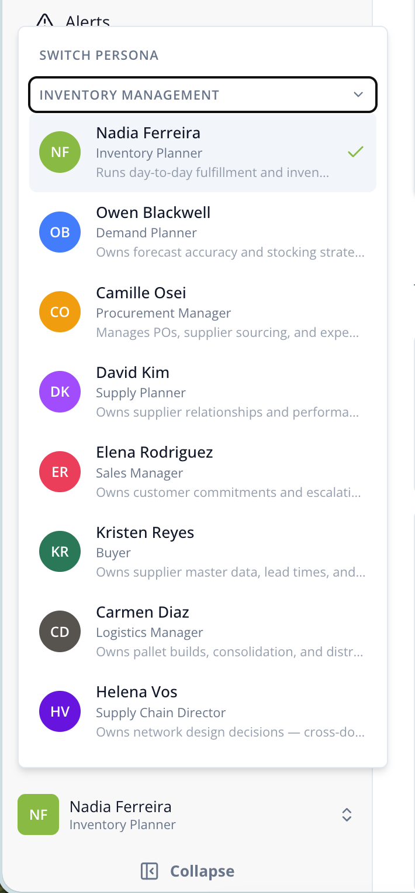

Move to Nadia’s persona profile
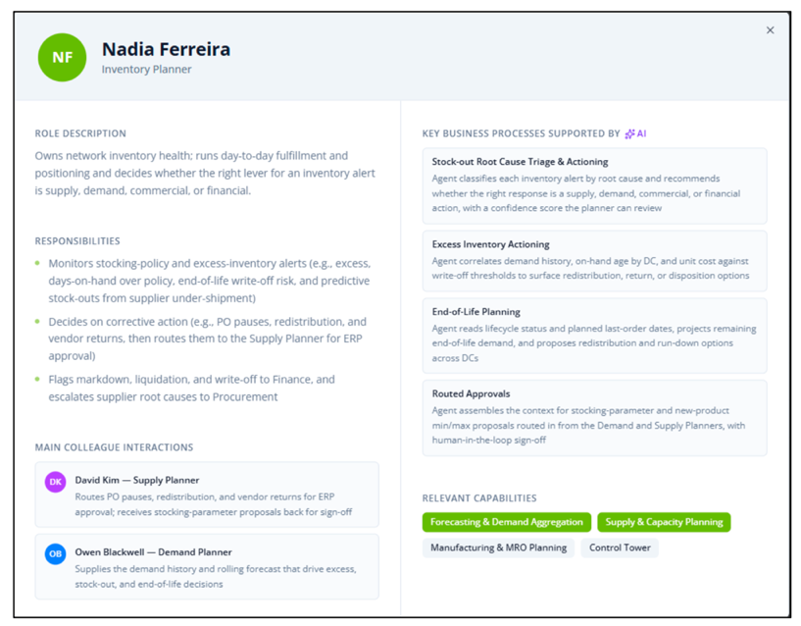

Nadia is responsible for maintaining service levels and balancing spare-parts inventory across the network. Her role profile also shows the processes she supports and the other people involved when a decision crosses functions.

The point of the persona model is to give the agent clear scope: what Nadia owns, what it may handle for her, and when a decision should move to someone else.

Move to Nadia’s Homepage

Now let’s look at Nadia’s home page.
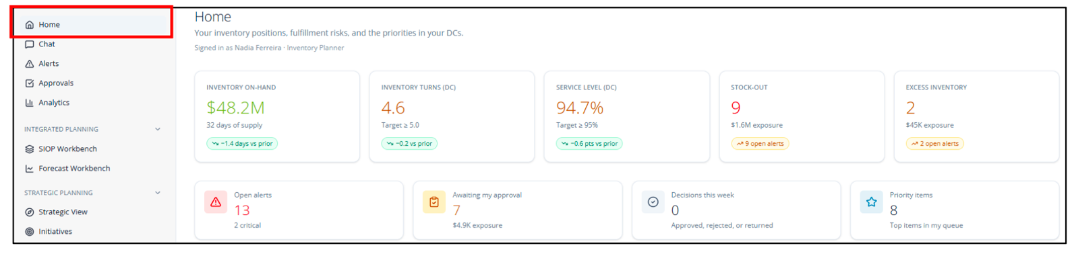
Rather than relying only on dashboards and static reports, Nadia works from a single view where the agent is continuously monitoring conditions and bringing forward issues that may require action.

The agent monitors inventory and demand, identifies risks, and proposes actions with supporting reasoning. This shifts Nadia’s time from gathering information to making decisions.

1:20–1:35 | Orient to Nadia’s work queue
Scroll to My priorities and point to the critical HX-600 Igniter Plug alert.
As you can see here, the agent automatically prioritizes the issues and recommendations that require Nadia’s attention. The agent has already assembled the context behind each of these items, so she is not starting with a list of unexplained alerts.
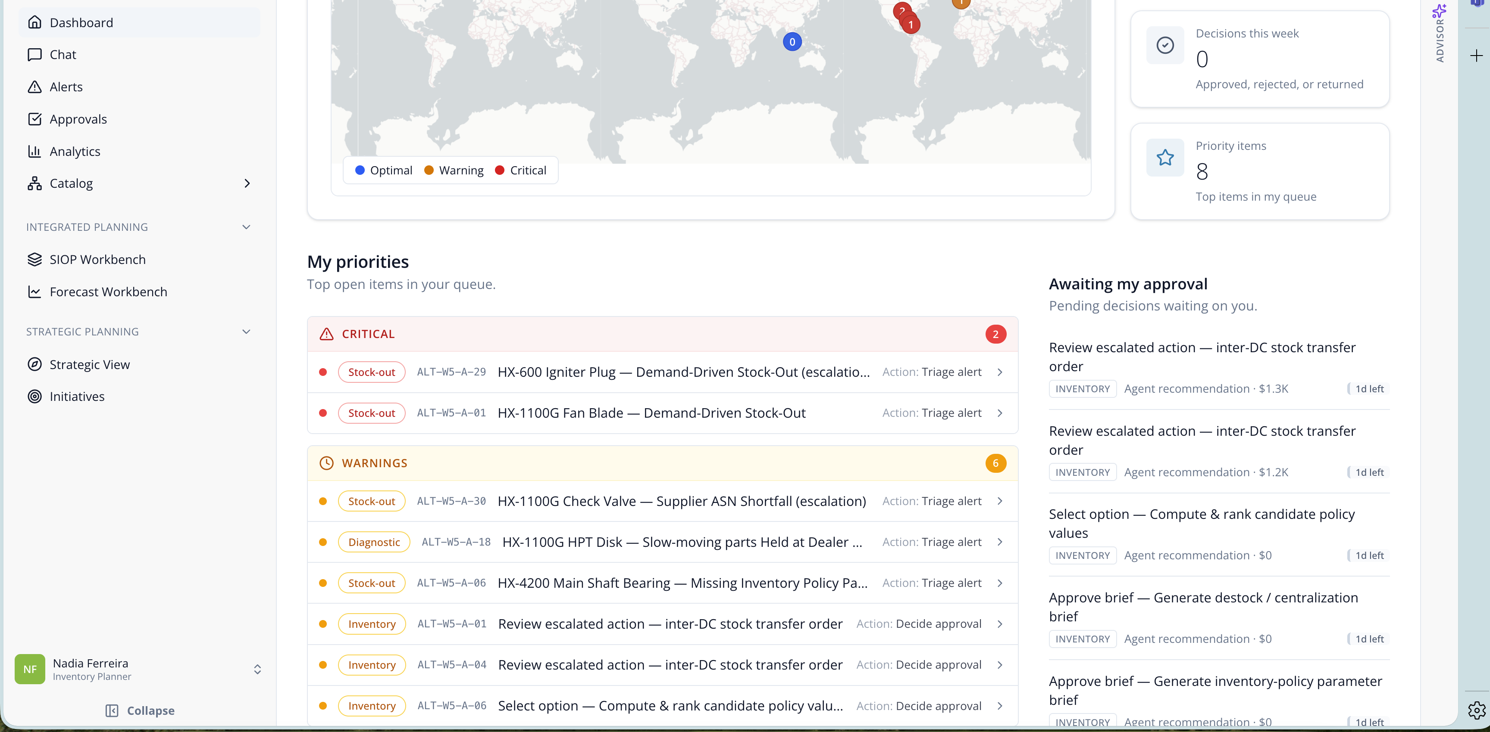

1:35–2:15 | Open the disruption and explain the agent’s analysis
Click the first priority –“critical HX-600 Igniter Plug — Demand-Driven Stock-Out” alert.
Here, the agent has identified a stockout involving a critical spare part. The screen provides the operational context, including why the disruption could affect maintenance schedules and asset availability.

Expand Reasoning.
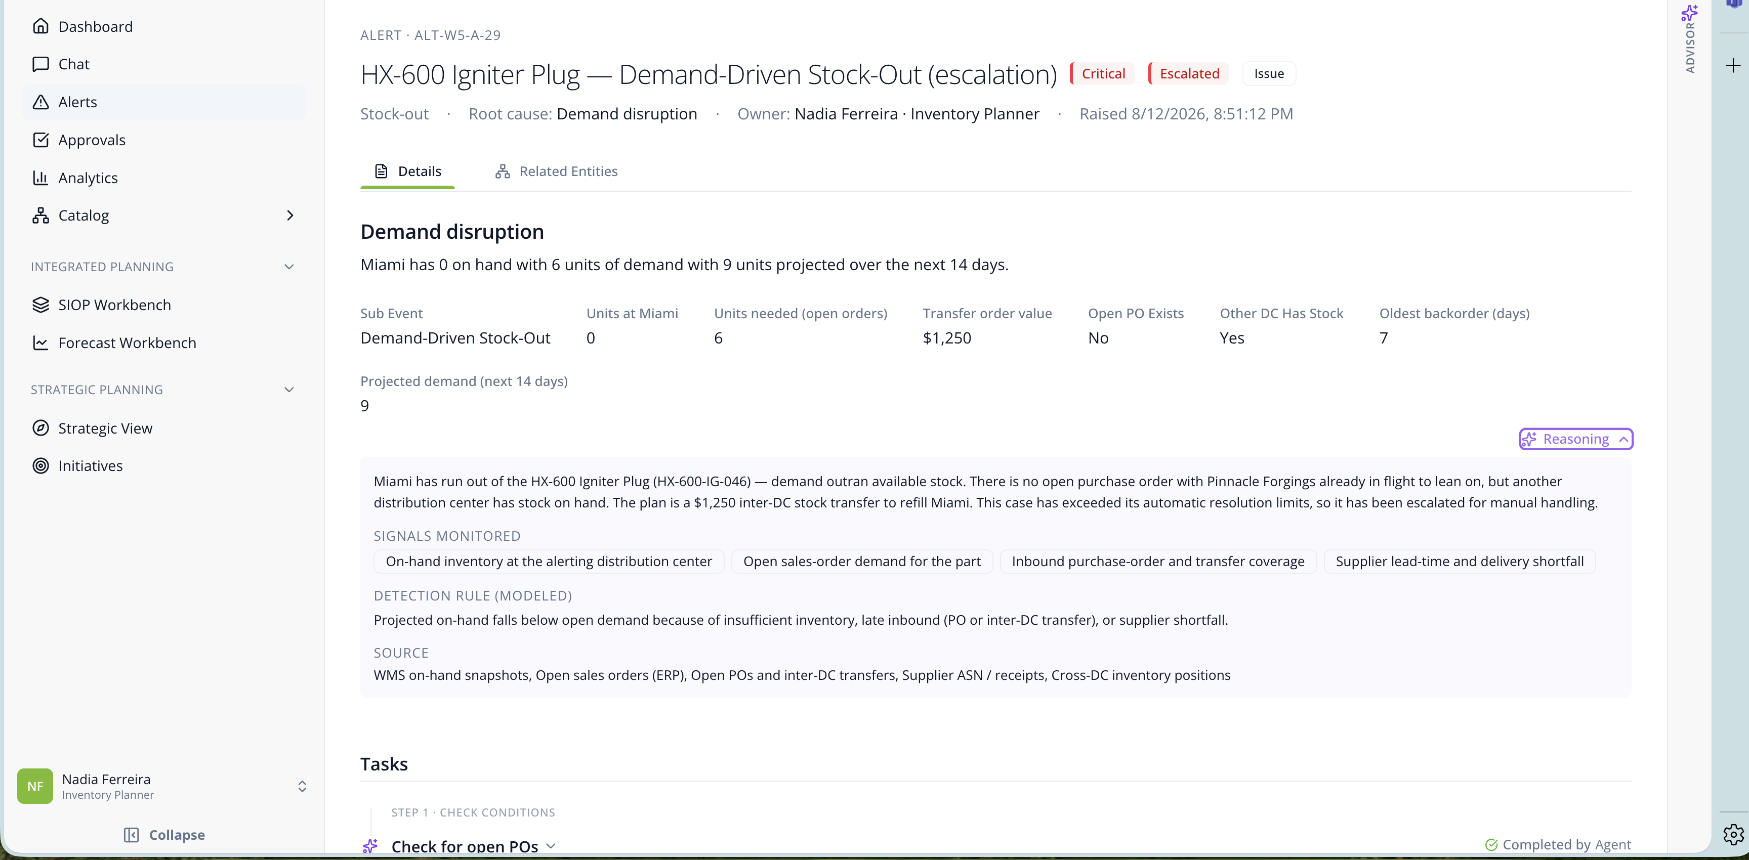
Before Nadia opened the alert, the agent has already done the analysis behind the scenes. It evaluated the relevant inventory, demand, and network availability, then prepared a recommended response rather than simply flagging the issue.

2:15–3:00 | Show agent work and the first human handoff
Scroll to Tasks. Expand Tasks. Pause on Approve / Reject.
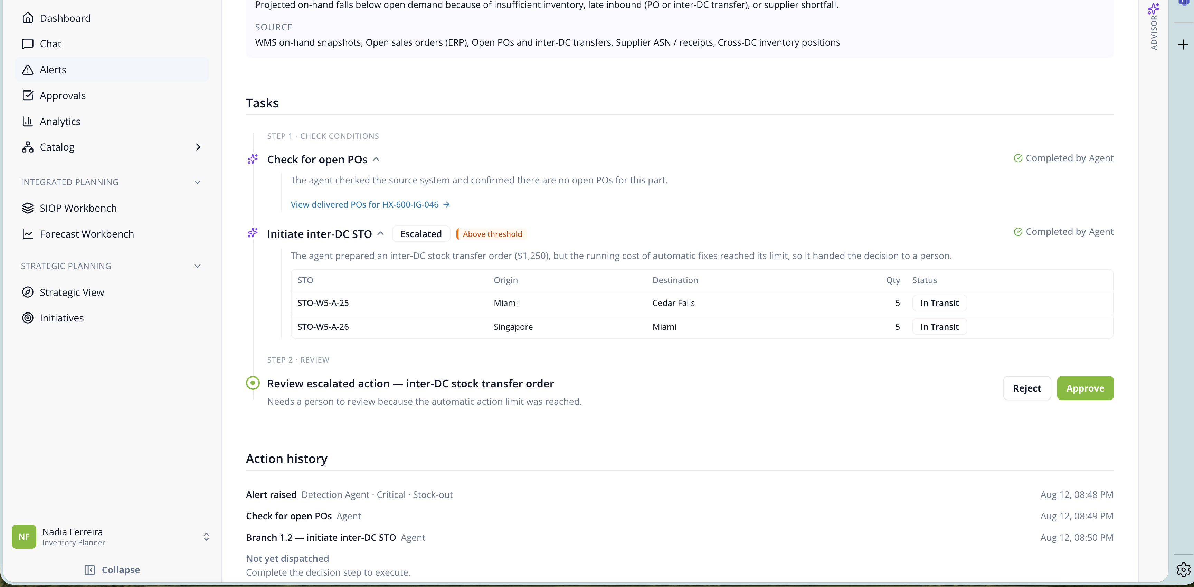
Here we can see the division of work. The agent completed the checks and prepared the transfer; those steps are already marked completed by the agent.
Nadia is reviewing a prepared decision, not starting an investigation. The reasoning view and outlined tasks give her enough evidence to validate the recommendation without recreating the analysis herself.
Because the action crossed a control threshold, it is handed to Nadia to approve or reject. These controls can be configured for persona and decision type, allowing routine work to move automatically while higher-impact decisions are escalated.

3:00–3:30 | Approve and show the agent resume
Click Approve. Point to the completed planner step, then the new emergency replenishment PO step and its approval.
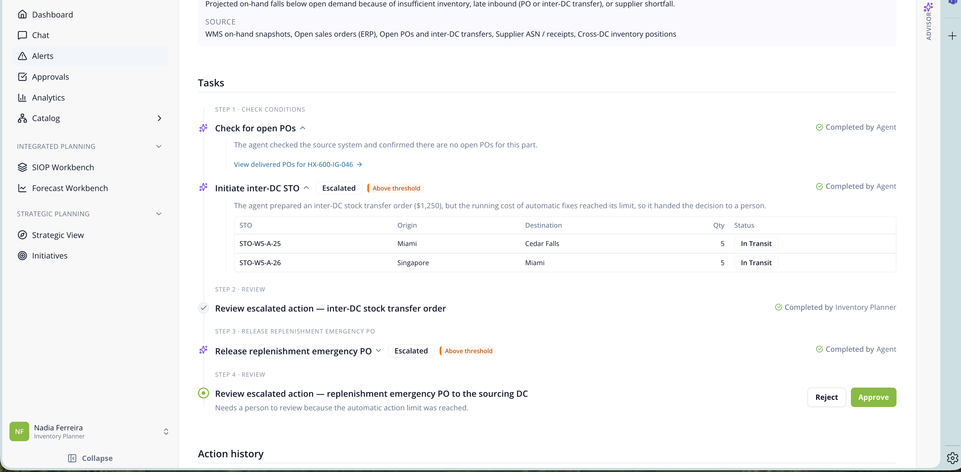
Once Nadia approves the transfer, control returns to the agent. While continuing the workflow, the agent identifies the another replenishment need, and prepares that action. Because this step also crosses a threshold, Nadia receives a second focused decision.

3:30–3:50 | Complete the decision and show traceability
Approve the replenishment step. Scroll to Action history.

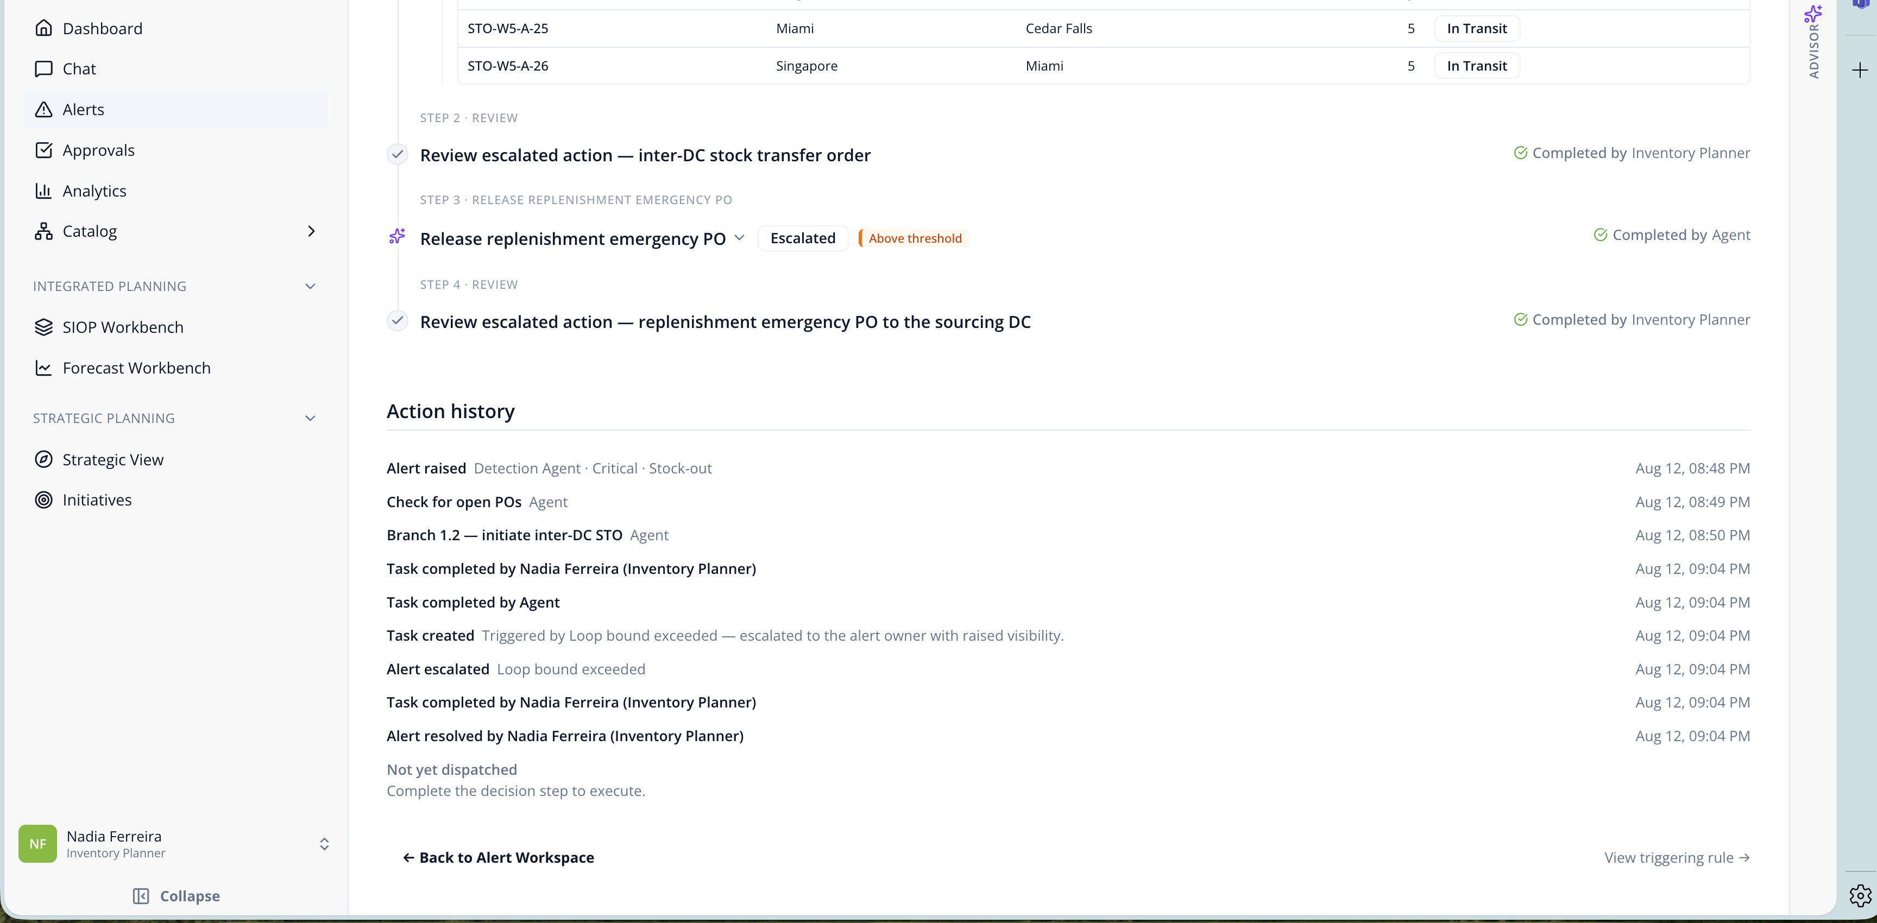
After the second decision, the alert is resolved. The history records what the agent did and what Nadia approved, providing a clear audit trail.

3:50–4:35 | Reveal the domain logic behind the workflow
Click “View Triggering Rule”
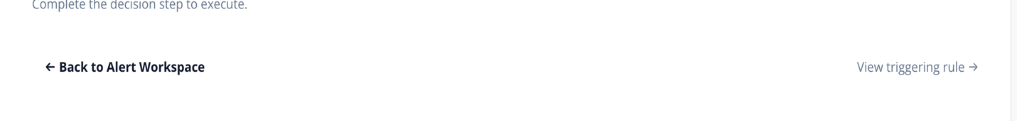
One thing to note about this solution – the AI logic behind the agent isn’t a black box. If you click “View triggering rule”, you can see all the logic behind it that helps you understand how the agent is working, what rules are determining how it predicts and responds to events.
All of this is developed not just for this one event, but for every event built into this system.

Scroll back to the top and click “Business Rules”, slowly scroll down.
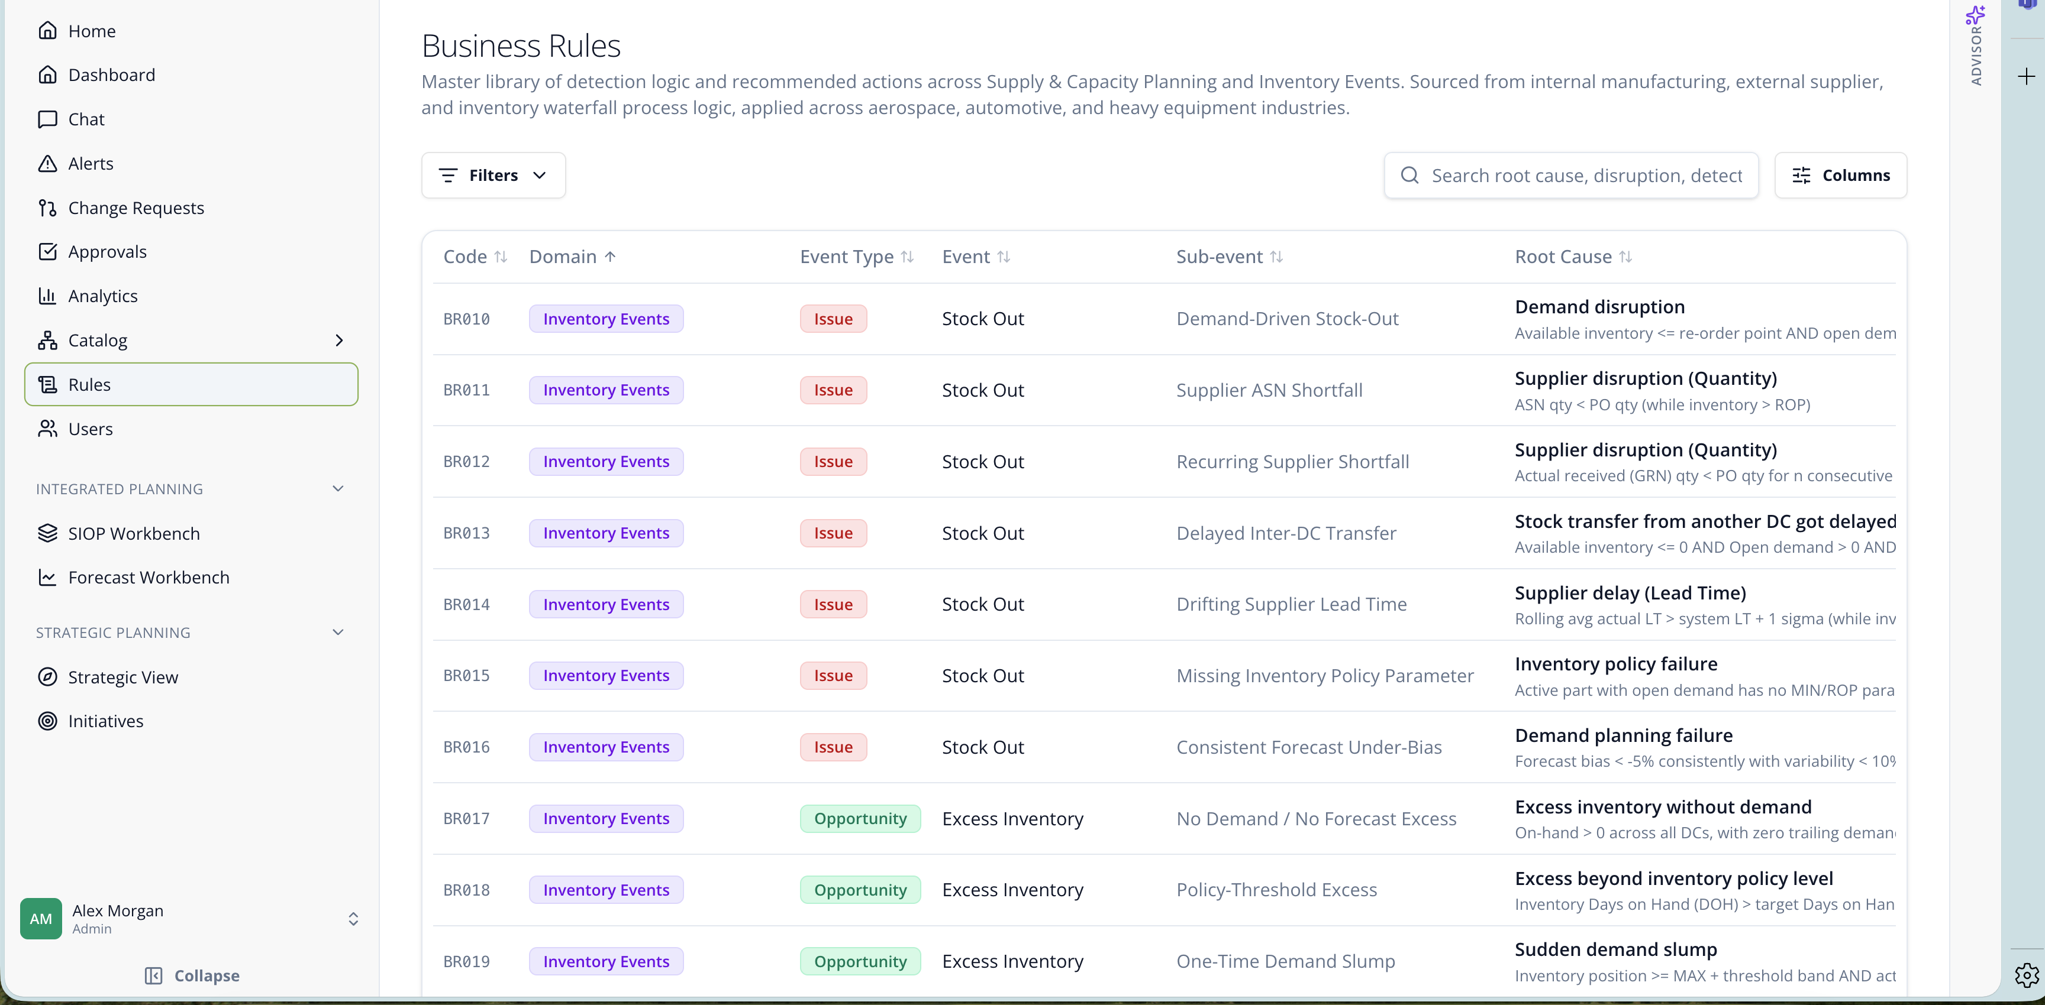
This library contains prebuilt aftermarket patterns that tell the agent what to watch for and how to respond. It includes issues, opportunities, diagnostic conditions, and data-readiness checks.

4:35–5:00 | Close the story
This is one of the solution’s core differentiators. The library starts with years of aftermarket experience translated into reusable rules. Customers can configure the thresholds and decision rights for their environment, and validated scenarios can be added over time. They are not starting from a blank prompt or rebuilding common aftermarket logic from scratch.

Heavy Equipment Inventory Planner Demo Script (5 min)
Research stimuli | Inventory Planner point of view

0:00–0:25 | Frame the point of view
Start on the Persona Menu
Before we begin, this prototype is shown through the day-to-day view of Nadia, an Inventory Planner. We chose this view because it shows best how the solution would work in practice. The solution supports several aftermarket personas, all working from the same underlying context.
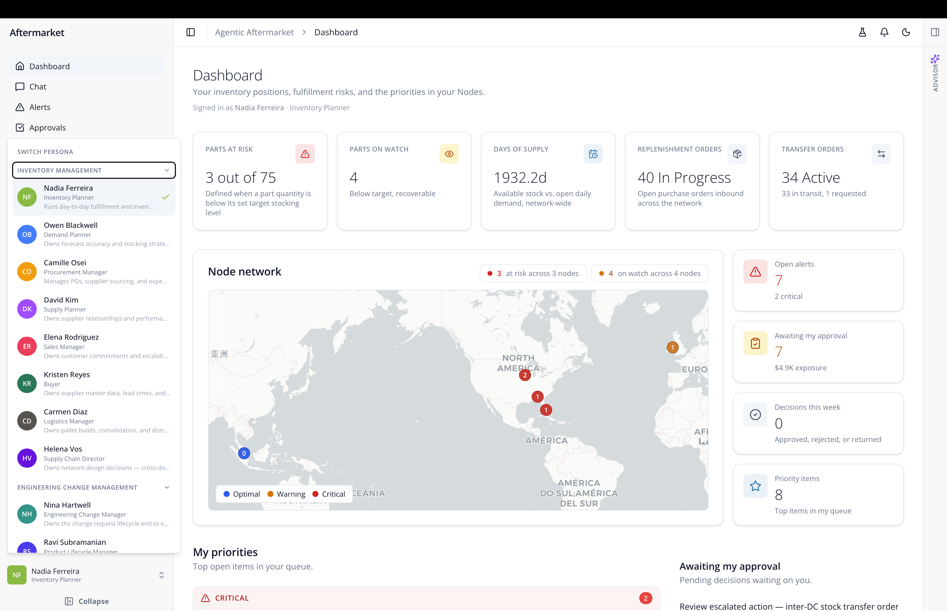

Open Nadia’s profile (under admin view)

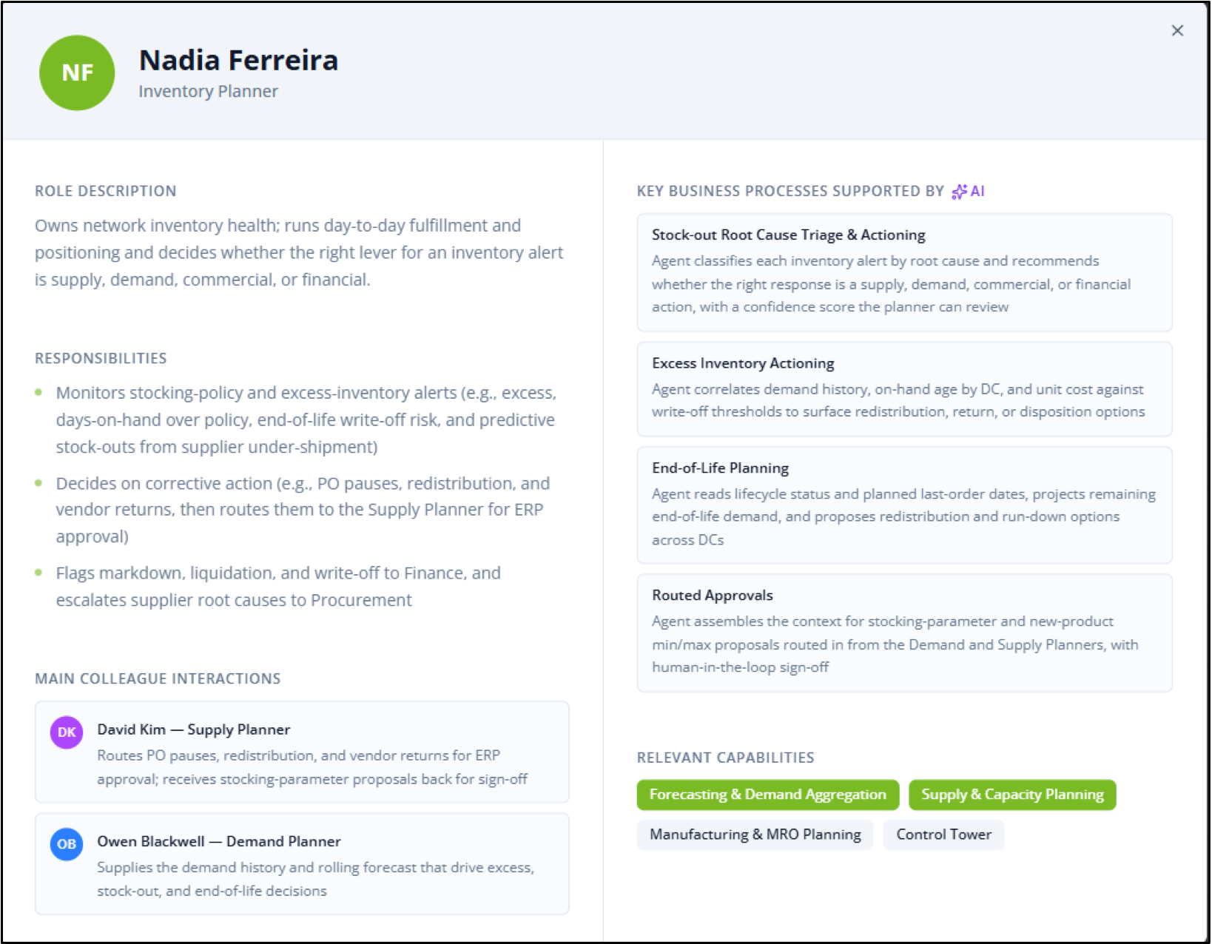
As you know, as an inventory planner, Nadia is responsible for maintaining service levels and balancing spare-parts inventory across the network. Her profile also shows the processes she supports and the other people involved when a decision crosses functions.
The point of the persona model is to give the agent clear scope: what Nadia owns, what it may handle for her, and when a decision should move to someone else.

Click Nadia’s home page.
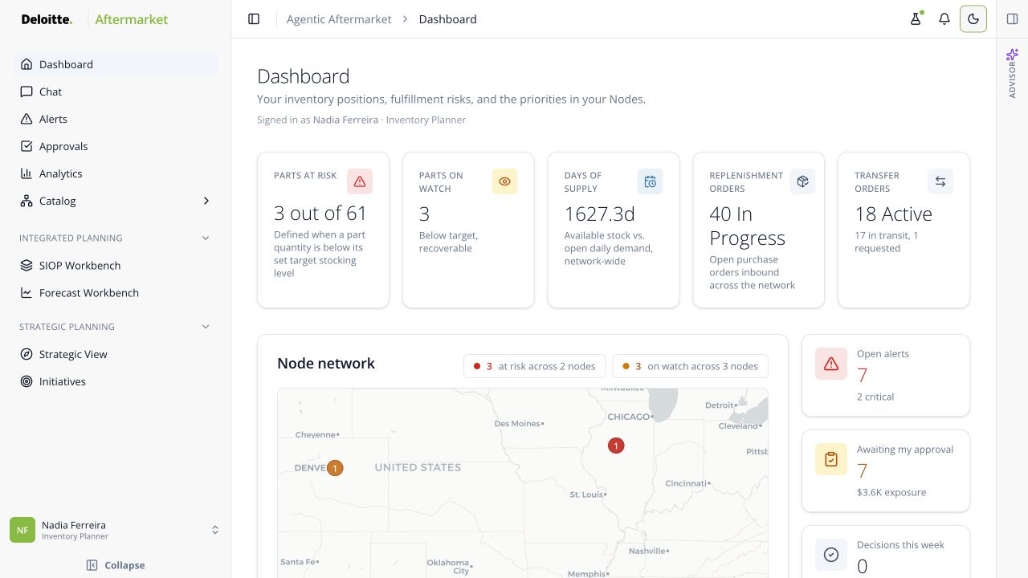
Now let’s look at Nadia’s homepage. Rather than relying only on dashboards and static reports, Nadia works from a single view where the agent is continuously monitoring conditions across the parts network and bringing forward issues that may require action.
The agent monitors inventory and demand, identifies risks, and proposes actions with supporting reasoning. This shifts Nadia’s time from gathering information to making decisions.

1:20–1:35 | Orient to Nadia’s work queue
Scroll to My priorities and point to the critical TX-450 Track Link Assembly alert.
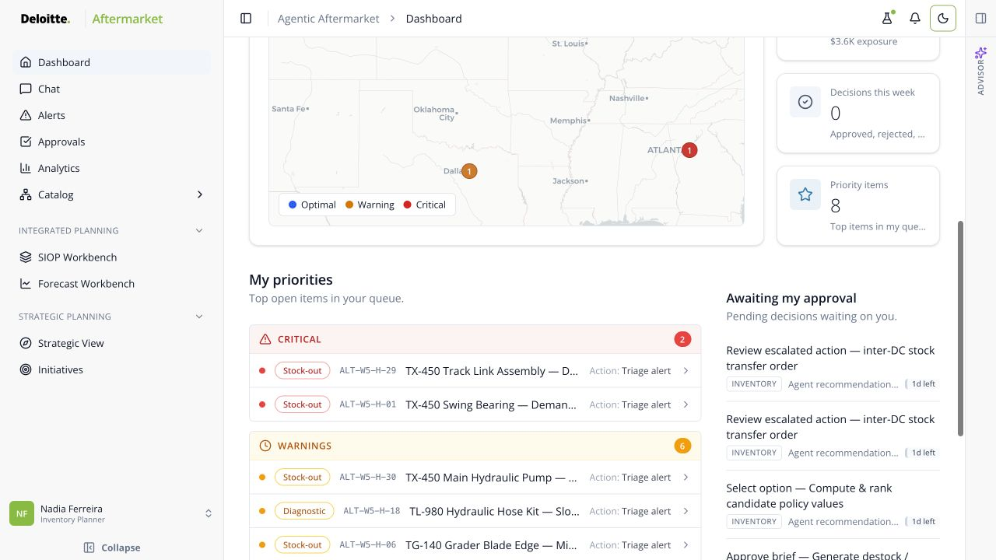

As you can see here, the agent automatically prioritizes the issues and recommendations that require Nadia’s attention. The agent has already assembled the context behind each of these items, so she is not starting with a list of unexplained alerts.

1:35–2:15 | Open the disruption and explain the agent’s analysis
Click the first priority, “TX-450 Track Link Assembly — Demand-Driven Stock-Out” alert.
Here, the agent has identified a stockout involving a critical undercarriage component. If the part is unavailable where it is needed, a machine may remain out of service longer and the dealer or service location may miss its repair commitment.

Expand Reasoning.
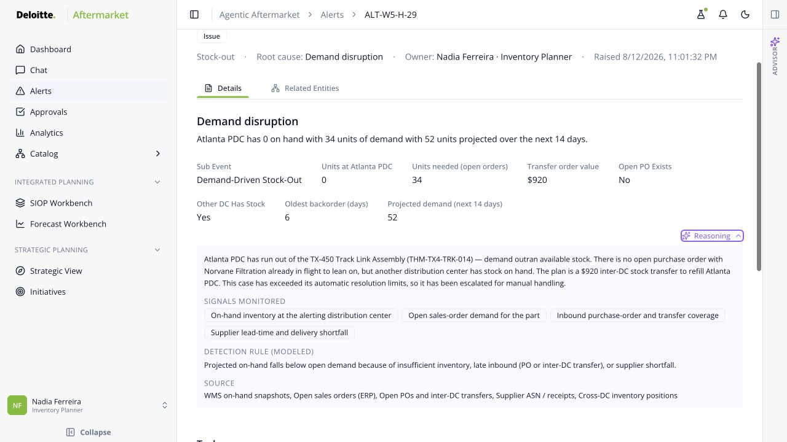
Before Nadia even opens the alert, the agent had already done the analysis behind the scenes. It evaluated the relevant inventory, demand, and network availability, then prepared a recommended response rather than simply flagging the issue.

2:15–3:00 | Show agent work and the first human handoff
Scroll to Tasks. Expand Check for open POs and Initiate inter-DC STO. Pause on Completed by Agent, Escalated, Above threshold, and Approve / Reject.
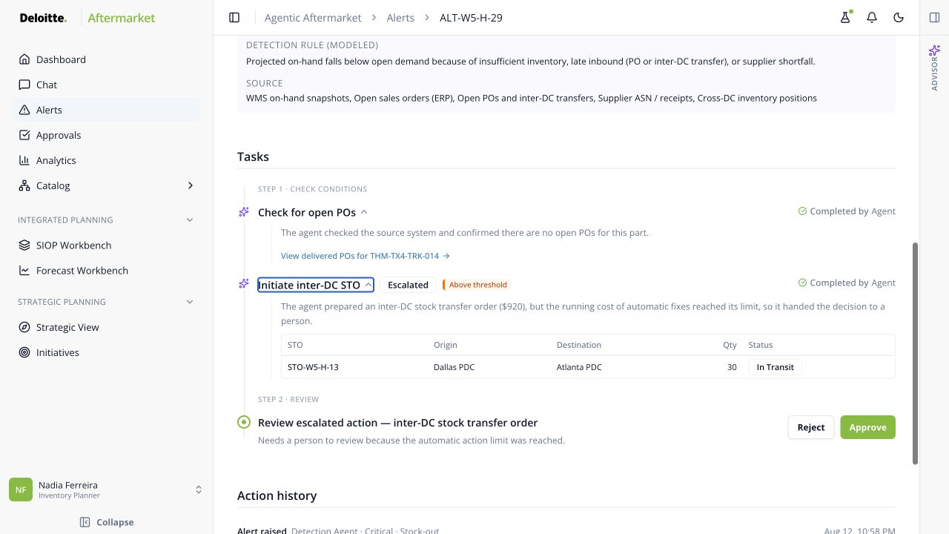
Here we can see the division of work. The agent completed the checks and prepared the transfer; those steps are already marked completed by the agent.
Nadia is reviewing a prepared decision, not starting an investigation. The reasoning view and outlined tasks give her enough evidence to validate the recommendation without recreating the analysis herself.
Because the action crossed a control threshold, it is handed to Nadia to approve or reject. These controls can be configured by persona and decision type, allowing routine work to move automatically while higher-impact decisions are escalated.

3:00–3:30 | Approve and show the agent resume
Click Approve. Point to the completed planner step, then the new emergency replenishment PO step and its approval.
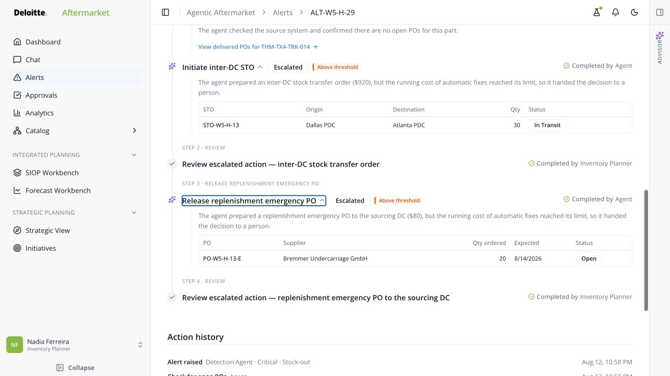
Once Nadia approves the transfer, control returns to the agent. It continues the workflow and prepares the replenishment action needed to protect the sourcing location. Because this step also crosses a threshold, Nadia receives a second focused decision.

3:30–3:50 | Complete the decision and show traceability
Approve the replenishment step. Scroll to Action history.
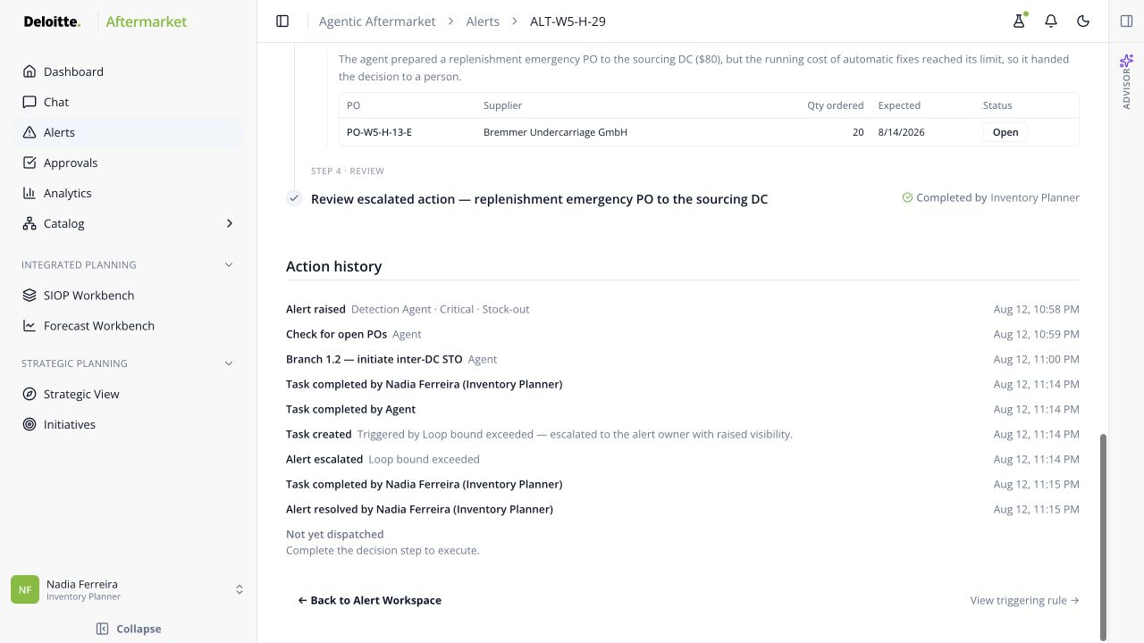

After the second decision, the alert is resolved. The history records what the agent did and what Nadia approved, providing a clear audit trail.

3:50–4:35 | Reveal the domain logic behind the workflow
Click “View Triggering Rule”

One thing to note about this solution – the AI logic behind the agent isn’t a black box. If you click “View triggering rule”, you can see all the logic behind it that helps you understand how the agent is working, what rules are determining how it predicts and responds to events.
All of this is developed not just for this one event, but for every event built into this system.

Scroll back to the top and click “Business Rules”, slowly scroll down.
This library contains prebuilt aftermarket patterns that tell the agent what to watch for and how to respond. It includes issues, opportunities, diagnostic conditions, and data-readiness checks.


4:35–5:00 | Close the story
This is one of the solution’s core differentiators. The library starts with years of aftermarket experience translated into reusable rules. Customers can configure the thresholds and decision rights for their environment, and validated scenarios can be added over time. They are not starting from a blank prompt or rebuilding common aftermarket logic from scratch.
RETURN TO GUIDE

